Create and modify

# Purpose

Using the Content Interface means that you adopt a slightly different approach to creating and modifying content for your Blackboard course site. The following provides an overview of this process.

**Never change content in Blackboard, always in the Word document**

The biggest change is that you no longer make changes to content by editing Blackboard content items. Instead, all changes are done in the associated Word document.

### A three-step process with two flavours

Which brings us to the three-step process you will use:

1. Create and modify content in a Word document.
2. Convert the Word document to HTML.
3. Copy that HTML into Blackboard.

There are two flavours of this method:

1. Entirely manual; or,
2. Semi-automated.

Which you use depends on how you **Error! Hyperlink reference not valid.**. Both are illustrated below.

## The cost trade off

When making a small change (adding a comma or fixing a spelling mistake) this three-step process does take longer (though you get quicker with time). It costs your time. The other main cost is that it does use Microsoft Word as the authoring environment. Which brings its own cost.

This cost, however, buys you additional functionality, including a better interface for students; and an editing environment that includes spell and grammar checking, citation management, version control and much more.

Increasingly, there are also more specific affordance offered including *University Date*. A way to write generic dates like *Wednesday, Week 5* (so that your content can be reused across multiple study periods) but have the right date for the current study period automatically added (to help you and students).

# The manual three-step process

The Content Interface code provides the overview of these three steps shown in Figure 1. The following sections illustrate those three steps.

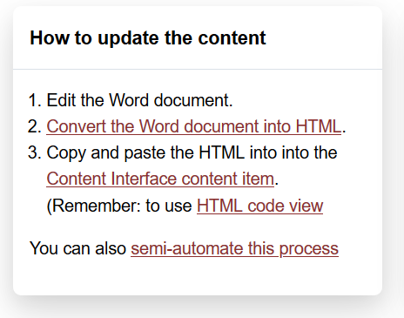

Figure 1 - Manual three steps - Content Interface instructions

## 1. Edit the Word document

The first step is to edit a Word document to create the content you want to place into Blackboard. How to do this is explained in more detail elsewhere. It does assume that you are familiar with styles in Word.

**Find out more about Word styles**

If you’re unfamiliar with using styles in Word documents, please refer to the plethora of online resources (e.g. [this one](https://shaunakelly.com/word/styles/tipsonstyles.html)). A quick search for *introduction word styles* should find most.

## 2. Convert the Word document into HTML

The next step is convert your Word document to HTML that is ready to pasted into your Blackboard content area. To do this, you will use this [web page](https://djon.es/gu/mammoth.js/browser-demo/) (Figure 2 - Mammoth conversion pageFigure 2) and the following steps.

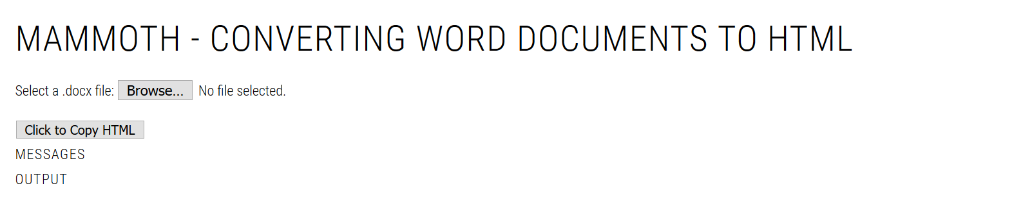

Figure 2 - Mammoth conversion page

**Acknowledgement:** The conversion of Word to HTML is enabled by a piece of [open source software called Mammoth](https://github.com/mwilliamson/mammoth.js).

### 1. Find your Word document

Use the **Browse** button to locate your Word document and load it up to the web page.

**You may need to close your Word document**

Depending on your set up, the following process may not work if you have the Word document open on your computer.

**Your Word document never leaves your computer**

This service works entirely in your Web browser. Your Word document is never loaded onto another computer.

### 2. Check the messages and output

Once uploaded, Mammoth will convert your Word document to HTML (e.g. Figure 3). It will display some messages and the output of the conversion process.

As shown in Figure 3 most messages you will see will report on element or styles from your Word document that Mammoth did not recognise. In most cases, these will be converted to a useful default.

Word does provide the capability to [search a document for particular styles](https://wordribbon.tips.net/T011741_Searching_for_Styles.html). This may be useful if you wish to fix these issues.

Mammoth produces a HTML version of your Word document. It will display it on the page. This can be useful for checking that any changes you’ve made have come through. However, how the HTML looks is not representative of what it will look like in Blackboard.

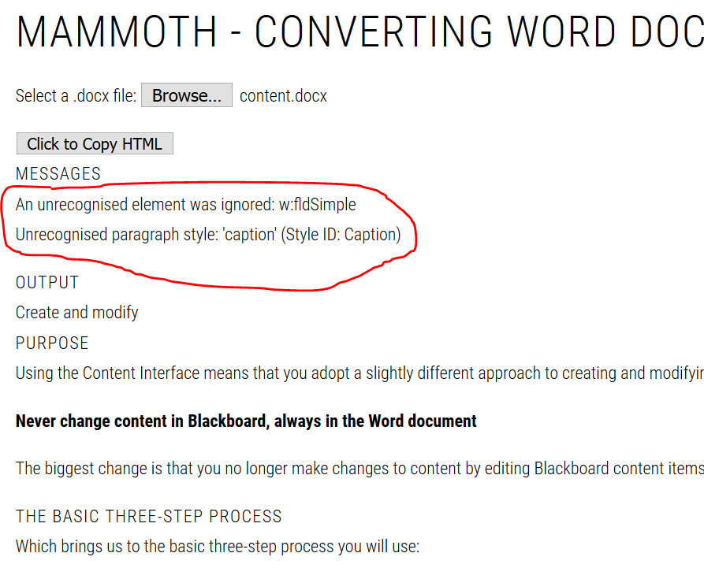

Figure 3 - Output of a successfully converted Word document

#### 3. Use the **Click to copy HTML** button.

This will copy the HTML produced by Mammoth into your computer’s clipboard ready to be pasted into Blackboard.

#### 4. Paste HTML into Blackboard

Having converted a Word document into HTML, it’s time to paste the content into Blackboard. To do this, you would:

1. Go to the Blackboard content area you prepared previously.
2. Edit the **Content Interface** item.  
   [This document](https://help.blackboard.com/Learn/Instructor/Course_Content/Create_Content/Edit_and_Manage_Content) explains how to edit a Blackboard item.
3. Paste the HTML code into this item.  
   Using the same [instructions](http://www.bu.edu/tech/services/teaching/lms/blackboard/how-to/copypaste-into-blackboard-learn/) from above for how to paste using the HTML Code View.
4. Update and Submit the changes.

# Semi-automated three-step process

If you have set up your Content Interface page to include a **Content Document** item then you will see Figure 4and can use the semi-automated three-step process.

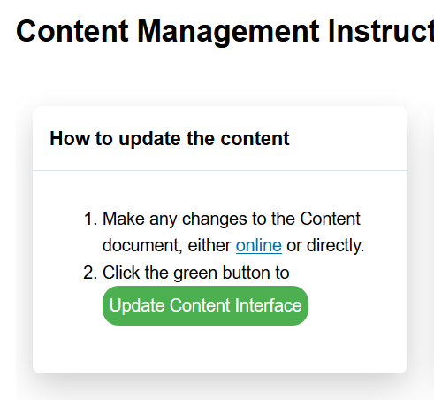

Figure 4 - Evidence you can use the semi-automated process

**Double check the Content Document link is a Word document**

To be sure that the semi-automate process will work, click on the **Content Document** item on your Blackboard page. For the semi-automated process to work, you should see an online version of the Word document.

## The video description of the semi-automated process

The annotated video below illustrates the semi-automated process. It assumes you’ve already edited the Word document and starts from step 2. The video will pause at certain points to provide time to consider what’s been shown. Press play to go to the next step.

<iframe src="https://griffith.h5p.com/content/1291061357553202529/embed" width="1088" height="637" frameborder="0" allowfullscreen="allowfullscreen" allow="geolocation *; microphone *; camera *; midi *; encrypted-media *"></iframe><script src="https://griffith.h5p.com/js/h5p-resizer.js" charset="UTF-8"></script>

## 1. Edit the Word document

Much of this is the same as editing talked about in the manual process. You use styles to create/edit content in Word.

### One difference - the online version

A major difference is that the **Content Document** points to an online version of the Word document, which you can edit. Meaning you can edit this document where ever you have access to the Web. You don’t need to be at your computer.

**But probably only for minor edits**

The web-based interface for Microsoft Word is somewhat different than the normal application. You may not wish to make major edits with this interface.

## 2. Convert to HTML

Once you have made all the changes to the Word document you need to convert the Word document to HTML.

To do this you click the **Update Content Interface** button as shown in Figure 4. This will start the conversion process and display something like Figure 5.

If the **PROGRESS** section is showing all green (and, perhaps some yellow) then the conversion process has been successful and the HTML version of your content will be displayed.

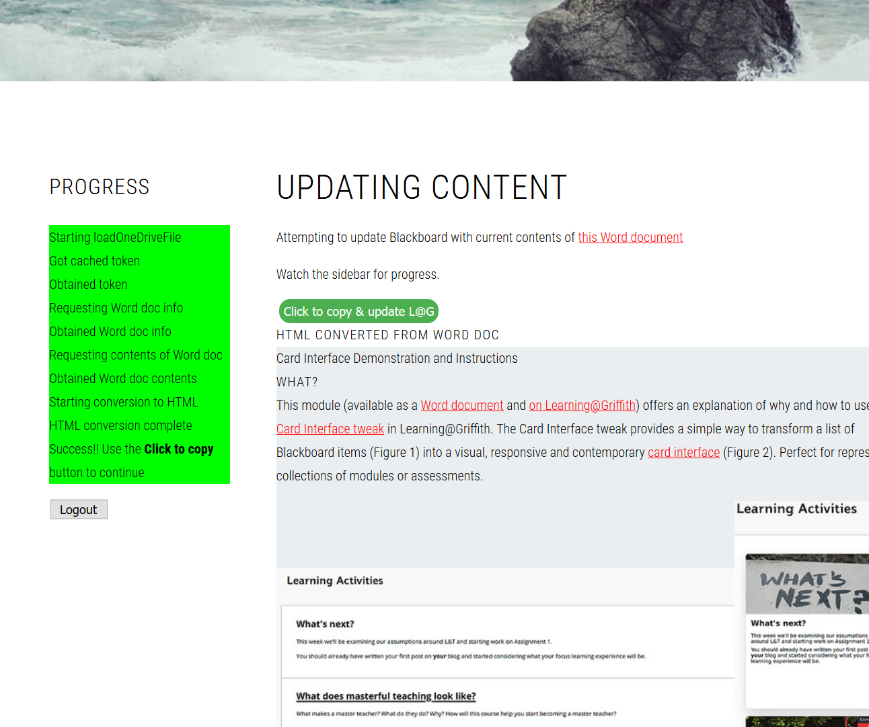

Figure 5 - Semi-automated conversion to HTML

## 3. Paste the HTML into Blackboard

Having converted the Word document to HTML, the next step is to make the change in Blackboard by pasting the HTML into Blackboard.

Do this by clicking on the **Click to copy & update L@G** button shown in Figure 5. This button will

1. Copy the HTML containing your updated content into your computer’s clipboard. (Ready for you to paste into Blackboard)
2. Take you back to Blackboard ready to edit the content item into which you need to paste the updated content.

If step #2 works, you should see something like Figure 6.

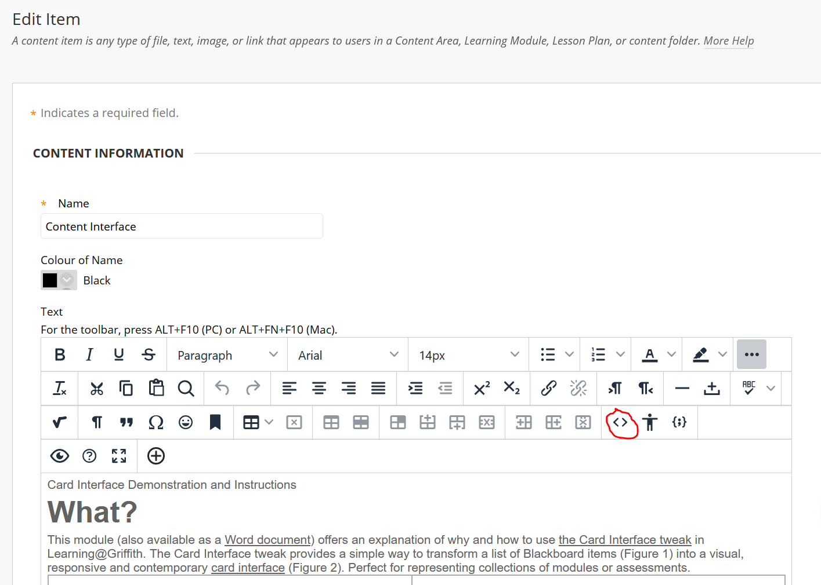

Figure 6 - Editing the content item (HTML button circled in red)

### Press the HTML button

Because the updated content is in HTML format, you cannot just paste it into Blackboard. You need to press the *HTML button*. This button is circled in red in Figure 6 and contains two angle brackets e.g. **< >**. You should then see something like Figure 7 pop up.

It shows the content of the Blackboard item in HTML. This is the content you will replace using the following steps

1. Delete all the content.
   1. Select all of the content by clicking in the *HTML code view* section and hitting CTRL-A (or Cmd A on a Mac).
   2. Hit the delete key to delete it
2. Paste in the updated content from the clipboard.
   1. Hit CTRL-V (or Cmd V on a Mac) to paste the clipboard contents.
3. Hit the *Update* button in the bottom right of the window.  
   This will take you back to the page shown in the previous image.
4. Hit the *Submit* button  
   This will take you back to the Blackboard page, which should be showing the updated content.

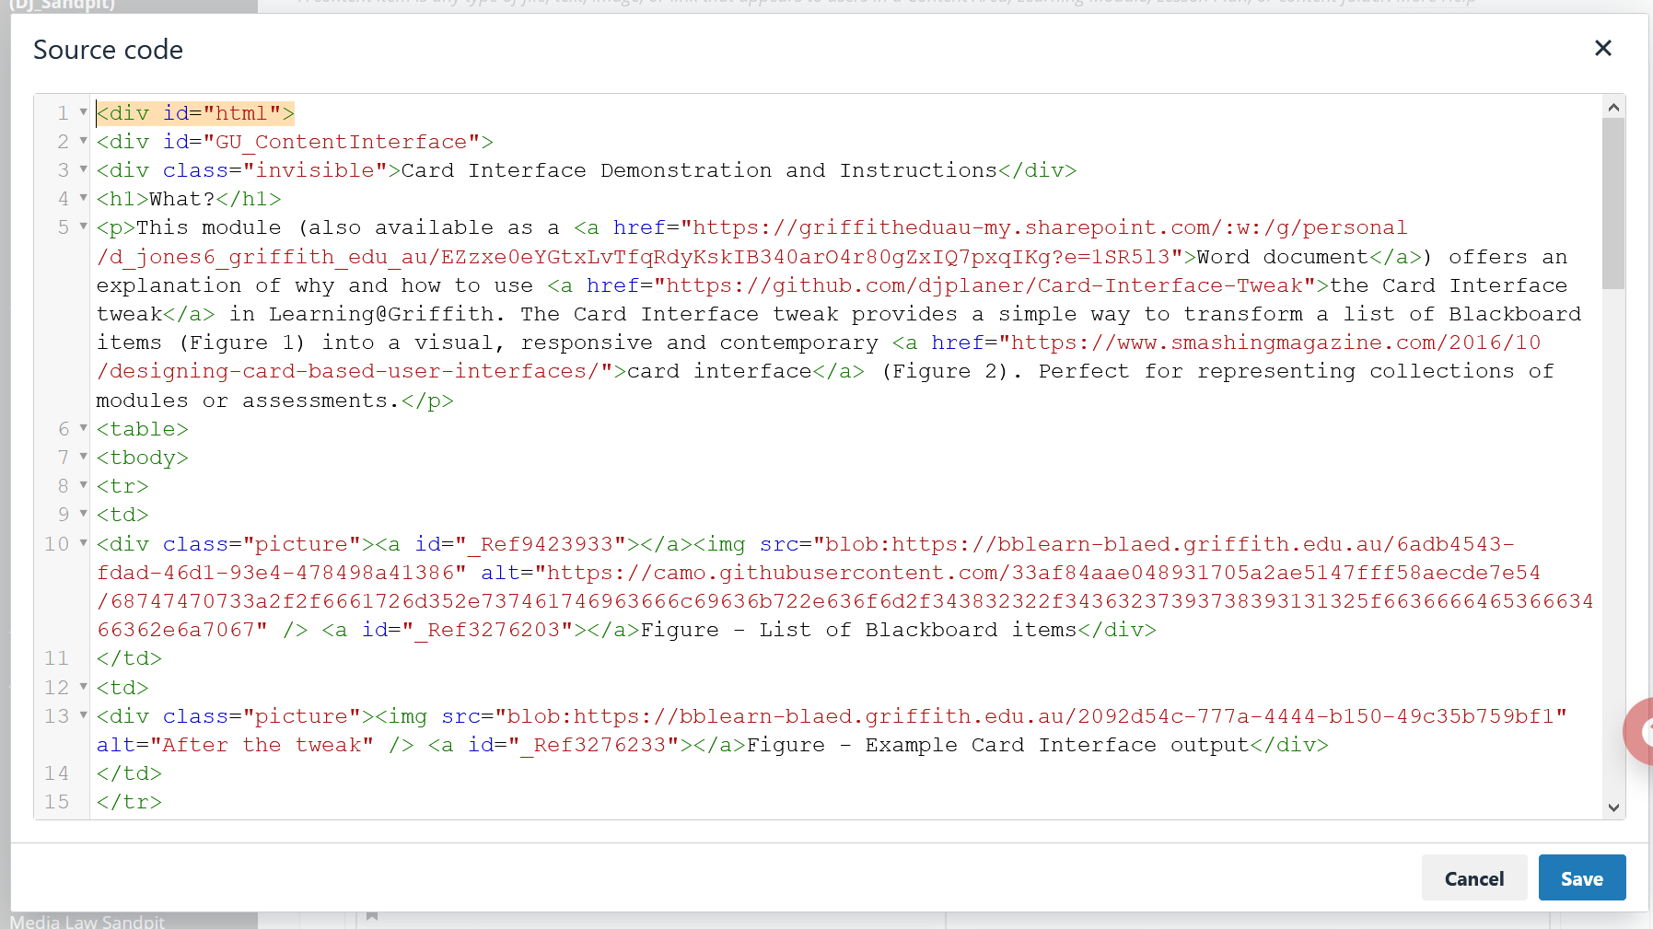

Figure 7 - The HTML code window